UBIQUITOUS CLOUDS AND THE INTERNET OF THINGS

5.1 Cloud Trends in Supporting Ubiquitous Computing
• Distributed computing has changed quickly in framework structure, size of operation, and application spaces recently. Clustered systems seemed first in the 1990s, which was confirmed by the expanding public of group organized hugely parallel processors in the top 500 supercomputer list. When we crossed into the 2000s grids wound up noticeably prevalent, showing up as huge scale groups of PC clusters. In any case, the overall population has not grasped lattices because of their absence of adaptability all in all reason applications.
• Since 2005, many distributed systems have showed up as document sharing systems and online social network. Indeed, ebooks, video streaming, picture downloads, and person to person communication to a great extent command Internet movement today. In any case, cloud do mirror the most recent advancement incline that accentuates versatility and adaptability by scaling out of registering administrations to computerized server farms through virtualization.
Use of Clouds for HPC/HTC and Ubiquitous Computing
• Pervasive distributed computing refers to the utilization of Internet assets at wherever and whenever for any targets. Today, individuals can get to the Internet by means of a stable wire or a portable remote association. Science in the cloud has been affected with another examination condition that uses programming and administrations being given on client request. New advances in look into revelation are normal in high-energy material science, observatory stargazing, air demonstrating, and biomedicine.
Large-Scale Private Clouds at NASA and CERN
• In 2010, two expansive scale private clouds were under development in the United States and European Union. We examine them in this area to show the adaptable development of distributed computing platforms. The U.S. cloud, called Nebula, is produced by NASA and is intended for NASA researchers to run atmosphere models on remote frameworks gave by NASA. This can spare a large number of NASA clients from obtaining supercomputers at their neighborhood destinations.
• Moreover, it empowers NASA to fabricate the mind boggling climate models around its server farms, which is more cost-effective. The EU cloud is worked by CERN in Geneva. This is an extensive private cloud for conveying information, applications, and processing assets to a huge number of researchers around the globe. CERN manages substantial informational indexes and throughput with a worldwide workforce and a limited spending plan. Numerous private clouds are additionally being worked on by the IT business, vast undertakings, and other government offices.
• At first, one can see that most clouds are created with limited client gatherings. Once these cloud wind up plainly develop and more secure to use to demonstrate their guaranteed favorable circumstances, they could be changed over to open cloud later on.
5.1.1 NASA’s Nebula Cloud
• Cloud is a distributed computing pilot a work in progress at NASA Ames Research Center as shown in Fig. 5.1. It coordinates an arrangement of open source parts into a consistent, self-benefit stage, giving high limit figuring, stockpiling, and system availability utilizing a virtualized, versatile way to deal with accomplish cost and vitality efficiencies. Cloud is at present being utilized for training and open effort, for coordinated effort and open info for mission bolster.
• Cloud upgrades NASA's capacity to work together with outer researchers and scientists by giving fast information associations and reliable instrument sets and open information APIs utilized by business cloud suppliers. Developed from the beginning standards of straightforwardness, Nebula is additionally an open source project. When finished, the Nebula stage will offer a turnkey processing arrangement that can quickly address the necessities of a substantial number of tasks.
• Every part of the Nebula stage will be accessible independently, serving SaaS, PaaS, and IaaS needs over the organization. NASA will utilize Nebula for mission support, training, and open effort and to energize cooperation and open information. In accordance with the Obama organization's endeavors to build up an open and straightforward government, Nebula will give NASA a simple, proficient, and secure approach to interface and offer information with general society.

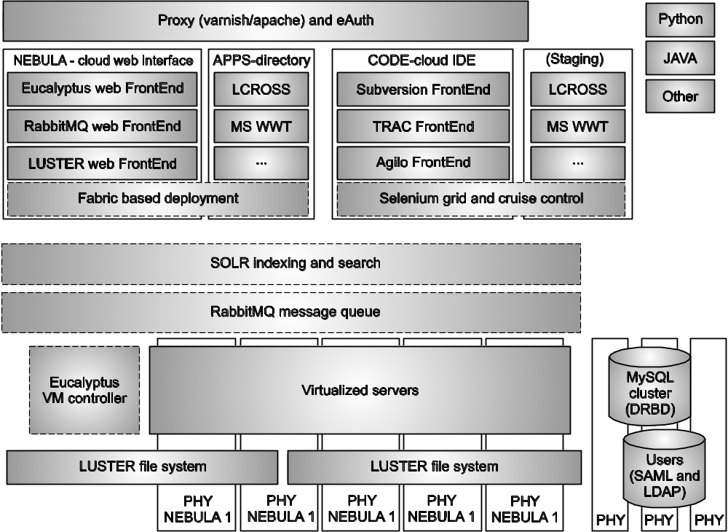
Fig. 5.1 : The Nebula cloud under development at NASA

5.1.2 CERN Super Cloud
• CERN has for quite some time been a compelling pioneer in taking care of complex IT issues. Indeed, the World Wide Web owes a ton to CERN for its handiness in completing some early work there. Presently, the emphasis is on distributed computing, CERN researchers intend to crush two molecule pillars together trying to re-make the "huge explosion" occasion to reveal the mystery of numerous principal material science marvels.
• The CERN researchers understand the utilization of distributed computing over their huge server farms might be more financially savvy in playing out the required recreation tests. A huge number of researchers around the globe are nourishing off the gigantic informational indexes and doing a wide range of research without anyone else's input.
• CERN trusts the cloud task will enable it to convey expanded processing execution and offer better framework administrations to its 10,000 analysts from 85 nations. At CERN, huge measures of logical information are prepared and should be appropriated to specialists in close ongoing. Therefore, CERN's cloud foundation needs to give the limit important to help generation and examination of more than 15 petabytes of information for each year, handled by 60,000 CPU centers, enabling researchers to oversee workloads themselves instead of a brought together IT administration division at CERN's lab close Geneva.
• Since CERN utilizes the stage's Load Sharing Facility (LSF) framework and workload administration answer for empower broad adaptability to dissect its immense measure of research information, the lab banded together again with the stage to investigate how to all the more adequately use their assets in a virtualized cloud condition. Stage LSF and its versatile group give an open, low-cost, common stage for CERN's researchers, permitting administration of both virtual and physical servers in the cloud. Also, researchers can deal with their own particular application conditions and control extends powerfully for greatest adaptability and proficient workload handling.
5.1.3 Cloud Mashups for Agility and Scalability
• In web application improvement, a mashup is a website page or application that joins information, presentations, or usefulness from at least two sources to make another administration. The principle attributes of the mashup are a mix of virtualization and accumulation. In distributed computing, the cloud has caught the processing market with dynamic asset portion from a pool of VM assets.
• Google's App Engine (GAE) is fundamentally determined by online administration offerings for capacity of records, messaging, and informing, among others. Not exclusively are AWS and GAE distinctive as far as their functionalities; however they additionally can supplement each other. This has set off squashing up various clouds to construct an intercloud or billow of clouds powerfully.
• Indeed, cloud mashups offer a more financially savvy answer for new businesses that would prefer not to put resources into cloud equipment and programming to make their own endeavor level server farm or private cloud. A cloud mashup must be intended to help famous ideal models, for example, MapReduce on AWS, but then be controllable by means of GAE through simple to-work web interfaces.
The Idea of a Cloud Mashup
• Any startup in the present business world needs to keep its operational costs low in the underlying years. This enables the business to recuperate its underlying speculations and post benefits rapidly. This, in turn, prompts investors to subsidize the organization with expectations of a snappy rate of profitability and the capacity to supply more money to enable the organization to develop. In this manner, it is important that the organization keep its underlying costs low.
• Consider a new business working in as a social network portal. It needs heaps of information storage room and servers, and additionally related cooling prerequisites and framework, for example, a physical working to house its hardware. This prompts a direct to expansive beginning speculation with respect to the organization.
• One can utilize the compensation per-utilize models from open clouds, for example, AWS and GAE to rapidly update the business as shown in Fig. 5.2. This cannot just guarantee that the misfortune because of time-to-advertise is reduced, but it can likewise upgrade the speed with which one can release another thought into the business world.
• Business mashups are additionally well known today as an ever increasing number of organizations can supplement each other pleasantly. The present mashups are ordinarily dataflow frameworks with the communication scripted in dialects, for example, JavaScript or PHP.
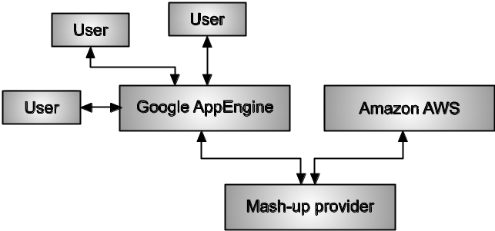
Fig. 5.2 : The concept of a mashup between
the GAE and AWS cloud platforms
Advantages of Cloud Mashups
• A new company that offers online applications including a lot of capacity and that depends fundamentally on its website page being up all the time ought to consider a cloud supplier offering a powerfully scaled (stack based scaling) instrument, as this would prompt expanded accessibility even with a sudden increment sought after, which is basic to new businesses. Additionally, the capacity to rapidly what's more, naturally downsize enables the business to keep operational costs low. The business processing stage needs to convey adaptable administrations, as well as deftness to survive and contend.
• A mashup can join a few stages or APIs to give a more extensive extent of administrations that enables greater adaptability and dexterity to clients :
• Scalability on the EC2 Virtual Clusters : Scaling the execution of MapReduce execution can be scaled regarding issue estimate and virtual bunch measure. As to measure, the USC tests run MapReduce from 1 VM hub to 40 VM hubs on the EC2 foundation. In this manner, scaling is all around investigated on EC2 to yield adaptable execution.
• Agility in utilizing GAE Interfaces : A mashup stage is worked by joining GAE and AWS, basically utilizing Google's web interfaces and Amazon's EC2 figuring power. We utilize GAE to make a site page that is equipped for transferring reports to GAE and running MapReduce on EC2. The mashup at that point sends the outcomes back to Google clients.
SLAs must be built up among cloud organizations with the goal that a consistent setup can be developed. The mashup supplier needs to give the usefulness physically. Absence of security among cloud suppliers could turn into a bottleneck for scaling applications past a couple of hundred clients. Be that as it may, this is precisely where the readiness of this approach becomes possibly the most important factor by enabling the course of action to be relocated effortlessly crosswise over stage limits. Building a private cloud stage may turn out to be significantly more powerful to investigate the adaptability and deftness of a mashup framework, particularly when the quantity of clients or informational collections develops quickly. By utilizing private server farms, the expenses of transferring information crosswise over geologically scattered cloud suppliers can be mitigated. Wide-run benchmark work is as yet required to approve the adequacy of the mashup cooperative energies.
5.1.4 Cloudlets for Mobile Cloud Computing
• Lancaster University proposed an ease framework to empower distributed computing utilizing cell phones. The thought is called Cloudlet, and it offers an asset rich entryway for updating cell phones with intellectual capacities to get to far off clouds. This entry ought to be intended to be dependable and utilize VMs to investigate area mindful cloud applications. The thought can be connected to circumstance revelation, quick data handling, and smart basic leadership out and about. Cloudlet makes it workable for cell phones to get to the internet cloud effortlessly in financially knowledge portable figuring administrations.
The Cloudlet Idea
• Portable handsets confront issues of restricted CPU control, stockpiling limit, and system data transmission on cell phones and tablet PCs. Cell phones can't be utilized to deal with extensive informational indexes. However, the far off cloud on the Internet faces the WAN inertness issue. Clouds need to take care of this impact issue of too much (millions) customers signing in to the cloud at the same time.
• To take care of this two-sided issue cloudlets are being sent at helpful locales, for example, coffee shops and book shops, like access focuses for WiFi administrations for associating with the Internet. Broadly conveyed cloudlets empower appropriated distributed computing and expanded asset taking care of for these clients. The thought is to utilize the cloudlet as an adaptable door or gateway to get to the far off cloud. The cloudlet can be executed on PCs, workstations, or ease servers. The significant advancement lies in utilizing VM-based adaptability to deal with demands from various cell phones.
Difference between Cloudlets and Clouds
As table 5.1 shows, cloudlets are decentralized and self-guided, similar to a "virtual server farm in a crate." Cloudlets work with LAN idleness and data transfer capacity with just a couple of clients at any given moment. Clouds are brought together everywhere scale server farms. They are professionally administrated constantly and they require vast machine rooms with continuous power and cooling. The fundamental issue for an inaccessible cloud to be gotten to by cell phones lies in the long idleness experienced with the Internet or WANs. The issue turns out to be more confounded when thousands or a large number of clients at the same time request administrations.
Table 5.1 : Difference between Local Cloudlets and Distant Clouds
 | Cloudlet | Cloud
State | Only soft state. | Hard and Soft state.
Management | Self-managed; little to no professional attention. | Professionally administered, 24x7 operator.
Environment | "Data Center in a box" at business premises. | Machine room with power conditioning and cooling.
Ownership | Decentralized ownership by local business. | Centralized ownership by Amazon, Yahoo!, etc.
Network | LAN latency/bandwidth. | Internet latency/bandwidth.
Sharing | Few users at a time. | 100-1000 of users at a time.
Mobility and Security Support in IoT Applications
Mobility support includes special air interface and mobile API designs and the use of wireless Public Key Infrastructure (PKI) for mobile access of cloud platforms. VPNs can be likewise used to secure cloud stages. Information insurance incorporates record/log get to control, information coloring, and copyright consistence. Catastrophe recuperation is likewise required if there should arise an occurrence of equipment/programming failures. Cloud security can be upheld by building up the base of trust, securing the VM provisioning process, utilizing programming watermarking, and utilizing firewalls and intrusion detection systems (IDSes)at the host and system levels.
5.2 Performance of Distributed Systems and the Cloud
In this segment, we will ponder the execution issues of both dispersed HPC (High Performance Computing) systems and clouds or server farm based HTC (High Throughput Computing) systems. HPC systems are progressing from Pflops execution in current supercomputers to exascale frameworks later on. HTC systems are fundamentally measured by the quantity of client undertakings that can be prepared per unit time (i.e., throughput). HTC systems are assessed as far as both throughput and Quality of Service (QoS).
Review of Science and Research Clouds
• FutureGrid
FutureGrid isn't a creation system, yet rather a domain supporting an adaptable improvement and testing stage for middleware and application clients taking a gander at interoperability, usefulness, and execution issues. FutureGrid will make it feasible for scientists to direct examinations by presenting an analysis arrange for that is then executed by means of a modern work process engine, protecting the provenance and state data important to permit reproducibility. One of the objectives of FutureGrid is to comprehend the conduct and utility of distributed computing approaches. Scientists can quantify the overhead of cloud innovation by asking for connected trials on both virtual and uncovered metal frameworks.
• Magellan
Magellan is the largest of the research clouds and is situated at two U.S. Department of Energy sites: Argonne and the National Energy Research Scientific Computing Center (NERSC) in California.
The systems are addressing a wide variety of research issues, including the following:
• Comparing cloud execution and conventional bunch and supercomputing conditions for logical applications. Specifically compelling are applications as of now running on nearby/departmental groups, or midrange applications that don't require more than 1,000 centers.
• Testing strong state (streak) stockpiling for information serious applications. Streak stockpiling offers generously expanded data transfer capacity and IOPS (I/O operation rate), and diminished idleness, particularly for read intensive applications.
• Exploring the convenience of utilizations to cloud frameworks, and specifically, taking a gander at MapReduce.
• Providing entrances on clouds to offer less demanding access to applications, databases, or computerized work processes.
• Testing elective resourcing models. For instance, where accessibility is pivotal, a virtual private bunch could ensure access to specific research bunches for particular timeframes.
• Understanding which logical applications and client groups are most appropriate for cloud figuring.
• Understanding the organization and bolster issues required to construct substantial science clouds. Is it financially savvy and down to earth to work science clouds? How could business clouds be utilized?
• Determining how existing cloud programming addresses the issues of science and in the case of expanding or upgrading current cloud programming enhances utility.
• Determining how well distributed computing underpins information concentrated logical applications.
• Determining the difficulties in tending to security for a virtualized cloud condition.
5.2.1 Data-Intensive Scalable Computing (DISC)
In 2007, Randal Bryant was among those who called attention to the increasing demand for data-intensive scalable computing.
• Big Data Sources: In the present information driven world, enormous databases are created from science in astronomy, genomics, natural languages, and seismic modeling, among different applications. Furthermore, checked books, newspapers, and authentic archives are making an information sea. In trade, corporate deals, securities exchange exchanges, registration information, and aircraft activity information all request the treatment of substantial informational collections once a day. Other great illustrations originate from the ranges of excitement and medication. The main case of huge information sources originates from the worldwide operations of Wal-Mart. Wal-Mart has 6,000 stores with supply chains including more than 10,000 producers. Every day, Wal-Mart offers 267 million things.
5.2.2 Performance Metrics for HPC/HTC Systems
HTC performance on business servers, clusters, data centers, and cloud systems is much more complex a problem to evaluate because the systems are used by many clients simultaneously. Thus, HTC performance is attributed to many orthogonal factors. Some of them are measurable and some are not. The basic assumption is that many (millions or more) independent users may use the shared resources in the cloud or data centers simultaneously. The goal is to satisfy as many concurrent users as possible, even if each user program is a simple web service, social contact, or simple cloud storage. In this section, we will see some performance evaluations and QoS assessment models for both HPC and HTC systems.
Basic Performance Attributes
• The execution models connected to assess MPPs, server farm groups, and virtualized clouds could be altogether different. To fit the layered structure of the distributed computing worldview, the execution measurements of IaaS fill in as a premise to show PaaS execution. So also, the model appropriate to display PaaS execution fills in as an establishment to assess SaaS execution.
• A decent model ought to have the capacity to cover every one of the layers of processing administrations. The model is non specific as it applies to different cloud stages under various workload appropriations. To evaluate QoS in cloud benefits, the effects on the best layer (SaaS) ought to stay straightforward to the lower layers (PaaS and IaaS).
• A cloud stage ought to be worked to serve numerous clients all the while. Subsequently, multitasking is a need to evaluate distributed system performance.
• Five basic performance metrics are introduced in this section: namely system throughput, multitasking scalability, availability measure, data security, and cost-effectiveness. This explanatory model offers a first-arrange estimate to display the execution of any HPC or HTC framework, including versatile clouds.
• One can simply add more execution credits to extend the model from the client's point of view to cover more measurements or those worries by specialist co-ops. As such, refined execution models could be reached out from fundamental credits to incorporate program conduct, natural request, QoS, and cost-adequacy.
System Throughput and Efficiency
• As a rule, the System throughput of a distributed system or a cloud stage measures the quantity of occupations that should be possible per unit of time. The throughput measure is credited to a few key factors that influence the aggregate execution time (T_{total}) of all occupations prepared in a given time window. First, we need to look at all segment times in T_{total}. Each activity submitted may encounter a start time to gain assets. This overhead time incorporates the boot time of all machine examples and the planning time of approaching client employments.
• The kind of the application program limits even adaptability.
• When all is said in done, the overhead can be ascribed to five parts: foundation start delay, asset provisioning delay, interjob correspondence delay, OS overhead, and stacking application programming overhead. The OS and programming overheads stay steady in running diverse employments. The other three time elements may change with issue size and system management policies.
Multitasking Scalability
• Multitasking suggests the utilization of a system to deal with many occupations at the same time or simultaneously. System administrations ought to have the capacity to scale both on a level plane over the machine or group measure and vertically from applications to middleware, runtime and OS support, and equipment.
• The capacity to scale assets powerfully is vital to give flexible assets. By even adaptability, we intend to increment cloud assets of a similar sort. For instance, the quantity of VM occurrences offers such a measure in a cloud. Vertical versatility implies the expansion in execution because of including more assets along the administration layers.
• For effortlessness in representing versatility, we focus on flat adaptability. Be that as it may, we consider both scale-up and downsize circumstances. Once in a while, downsizing could be more effective than scaling up. The potential advantage of a framework or cloud stage is generally ascribed to having the capacity to scale assets here and there powerfully, on request.
System Availability
System availability (γ) refers to the percentage of time the system is up and running normally. This percentage reflects the effects of downtime after unexpected failures and scheduled maintenance for software upgrades.
Quality of Service in Cloud Computing
The cumulative performance of a cloud platform by a compound metric, called Quality of Cloud Services (QoCS) and denoted by θ. This metric measures the overall quality of the cloud service, regardless of the particular service models applied.
5.3 Enabling Technologies for the Internet of Things
In ubiquitous computing, the Internet of Things (IoT) gives a system of sensor-or radio associated gadgets that can be particularly distinguished and situated in the digital physical space. This IoT is generally remotely associated as a self-designing system of radio-recurrence labels, minimal effort sensors, or e-labels. The expression "IoT" consolidates RFID innovation with the present IPv6-based Internet innovation. All things (objects) have IP addresses, which can be remarkably recognized. The IP-identifiable items are comprehensible, unmistakable, locatable, addressable, or potentially controllable by means of the Internet, supported by RFID, WiFi, ZigBee, mobile networks and GPS. The IoT empowering advances are canvassed in this area for protest labeling, remote sensing, and finding positions.
5.3.1 The Internet of Things for Ubiquitous Computing
• The IoT is a characteristic extension of the Internet. The establishment of the IoT is radio-frequency identification (RFID). This empowers the disclosure of labeled items and cell phones by perusing an IP address or scanning for a database section. Though RFID is a sort of single adaptable cell of the inescapable registering world, the IoT presents a dream without bounds. In the nineteenth century, PCs figured out how to do as trained. In the twentieth century, PCs figured out how to think. In the twenty-first century, PCs want to learn how to perceive by sensing and understanding.
• Ordinary articles incorporate electronic gadgets, as well as items, for example, people, creatures, nourishment, garments, homes, vehicles, products, trees, slopes, and milestones. The IoT framework could enormously diminish the odds of an organization coming up short on stock or squandering items, as every single concerned gathering would know precisely what items are required. Misplaced things and physical burglary would be influenced by the way that the area of a thing would be known to all gatherings. This requests all items on Earth be radio-labeled, extending from a drain container to a truck holder to a huge fly. PCs recognize and deal with every labeled protest similarly people do. This IoT framework will enhance our personal satisfaction and make society cleaner and more secure, advantageous, and pleasant.
Architecture of the Internet of Things
• The IoT framework is probably going to have an occasion driven engineering. In Fig. 5.3, IoT improvement is appeared with a three-layer design. The top layer is shaped by driven applications. The base layers speak to different sorts of detecting gadgets: in particular RFID labels, ZigBee or different sorts of sensors, and street mapping GPS pilots. The detecting gadgets are locally or wide-range associated in the type of RFID systems, sensor systems, and GPSes. Signs or data gathered at these detecting gadgets are connected to the applications through the distributed computing stages at the center layer.
• The signal processing clouds are worked over the mobile networks, the Internet backbone, and different data systems at the center layer. In the IoT, the significance of a detecting occasion does not take after a deterministic or syntactic model. Truth be told, the SOA display is adoptable here. An expansive number of sensors and channels are utilized to gather the crude information. Different register and capacity clouds and lattices are utilized to process the information and change it into data and learning positions. The detected data is utilized to assemble a decision-making system for knowledge applications. The center layer is likewise considered as a Semantic web or grid. A few performing artists (administrations, segments, symbols) are self-referenced.

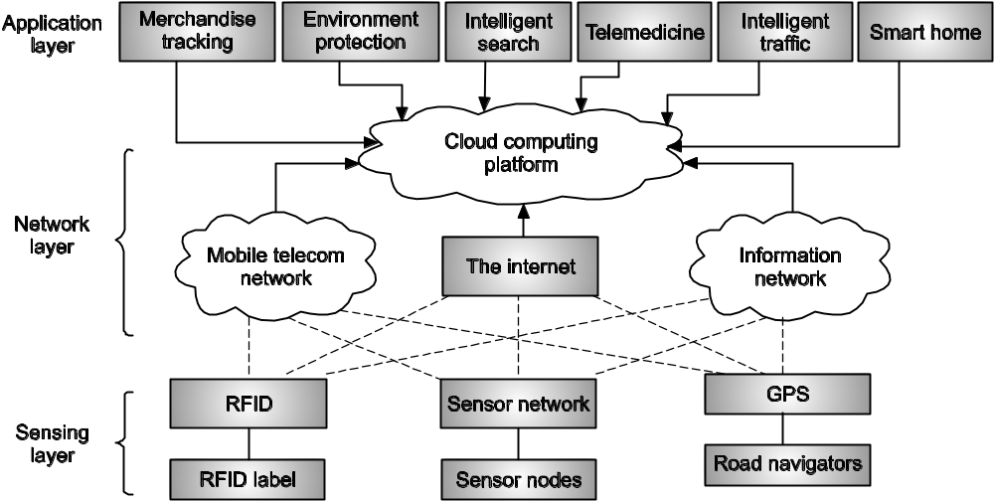
Fig. 5.3: The architecture of an IoT

5.3.2 Radio-Frequency Identification (RFID)
RFID is connected with electronic marks or RFID labels on any items being observed or followed. The labeling might be connected to any articles, for example, stock, devices, cell phones, PCs, creatures, or individuals. The reason for existing is to recognize and track the items utilizing radio waves or detecting signals. Some labels can be perused from tens or several meters away by means of a remote reader. Most RFID labels contain no less than two noteworthy parts. One is a coordinated circuit for putting away and handling data, adjusting and demodulating a radio-recurrence (RF) flag, and other exceptional capacities. The other part is a reception apparatus for getting and transmitting the radio signs.
RFID Tags and Device Components
There are by and large three sorts of RFID labels: active RFID labels containing a battery and transmitting signals independently, passive RFID labels which have no battery and require an outside source to incite flag transmission, and battery-helped aloof RFID labels which require an outer source to awaken the battery however have essentially higher forward connection ability. In light of the radio recurrence utilized, the passive RFID labels work with from low frequency (LF) to high frequency (HF), ultra high frequency (UHF), and the microwave extend. As far as usefulness, there are three noteworthy parts of RFID equipment:
1. RFID label A minor silicon chip connected to a little receiving wire.
2. Reader reception apparatus Used to emanate the vitality and after that catch the arrival flag sent once again from the tag. It can be incorporated with a handheld reader gadget or associated with the reader by link.
3. Reader The gadget station that discussions with the labels. A reader may bolster at least one reception apparatus. Taking after an electronic scanner tag, a reader gadget can distinguish flags even without a viewable pathway. Some RFID readers can recognize different questions simultaneously. Also, some RFID tag-reader structures bolster security highlights, for example, requiring a human administrator to enter a test code before deciphering an ID. RFID gadgets have fluctuating sizes, control necessities, working frequencies, amounts of rewritable and nonvolatile stockpiling, and programming insight. They work from a couple of centimeters to many meters. In any case, bigger gadgets having an internal power source have a tendency to work at longer ranges. On the other hand, extremely littler gadgets have no internal power source.
How RFID Works ?
• Developments in RFID incorporate active, semi-active, and inactive RFID labels. These labels can accumulate to 2 KB of information and are made out of a microchip, antenna, and battery for active and semi-passive labels. The label's segments are encased inside plastic, silicon, or now and then glass. Information put away in the microchip holds up to be perused. The label's reception apparatus gets electromagnetic vitality from a RFID reader's radio wire. Utilizing power from its inside battery or power gathered from the reader's electromagnetic field, the label returns radio flags back to the reader. The reader grabs the label's radio flags and translates the frequencies as important information.
• There are two approaches to couple conspires in RFID labels: inductively coupled or capacitively coupled. RFID labels are still not in broad use by customary individuals, since they are costly and cumbersome. They are all the more regularly utilized by extensive organizations, moving or sending organizations, and administration organizations. Be that as it may, RFID labels can make our everyday life or work considerably much easy, more helpful, and available to noticeable or concealed articles encompassing us. These labels are not that costly to create in vast amounts, and they can be made sufficiently little to fit on any item or object. Outer RF reception apparatus gadgets can enlighten the label gadgets like radar lighting up an objective.
• In any case, RFID is more viable at working at shorter extents. An assortment of offices are characterizing the principles and managing the utilization of RFID. They incorporate the International Organization for Standardization (ISO), International Electrotechnical Commission (IEC), ASTM International, DASH7 Union, and EPCglobal.
• RFID has numerous modern applications including stock following and production network administration. Its utilization can enhance the effectiveness of stock control and precision of sequential construction system administration.
• Active and semi-passive RFID labels utilize inside batteries to control their circuits. An active tag can likewise utilize its own particular battery to communicate radio waves to a reader, while a semi- passive tag depends on the reader to supply its energy for broadcasting.
• Active and semi-passive labels are held for perusing 30 to 100 meters, if repeater batteries are utilized to support a label's range. For instance, a client finds a couple of shirts of her size on a store rack with a radio band gave by the store. She can arrange the dress and pay by means of her mobile phone with the assistance of a RFID setting.
• Passive RFID labels depend completely on the reader as their energy source. These labels are read just up to 20 feet away. They have bring down creation costs, which means they can be connected to more affordable stock. These labels are produced to be dispensable. A railway car may apply active RFID tags. A bottle of shampoo may use only a passive tag. Another factor that impacts the cost of RFID labels is data storage.
• There are three stage types: read-write, read-only, and write-once-read-many (WORM). A read-write label's information can be added to or overwritten. Read-only labels can't be added to or overwritten. WORM labels can have extra information included once, yet they can't be overwritten. Most passive RFID labels cost 7– 20 cents each Active and semi-passive labels are more costly, and RFID producers ordinarily do not cite costs for these labels without first deciding their range, storage type, and quantity.
5.3.3 Sensor Networks and ZigBee Technology
The present sensor systems are generally wireless, and are known as wireless sensor networks (WSNs). A run of the mill WSN comprises of distributed autonomous sensors to agreeably screen physical or natural conditions, for example, temperature, sound, vibration, weight, movement, or contaminations. The advancement of wireless sensor networks was roused by military applications, for example, war zone observation. WSN innovation is presently utilized as a part of numerous mechanical and non military personnel application territories, including process observing and control, machine wellbeing checking, condition and natural surroundings observing, medicinal services and home computerization, and astute activity control.
Wireless Sensor Networks
• A WSN is a gathering of particular transducers with an interchanges foundation expected to screen and record conditions at different areas. Normally checked parameters are temperature, dampness, weight, wind heading and speed, light force, vibration power, sound power, control line voltage, substance fixations, contamination levels, and crucial body capacities.
• A sensor arrange comprises of different discovery stations called sensor nodes, each of which is little, lightweight, and convenient. Each sensor node is furnished with a transducer, microcomputer, handset, and power source.
• The transducer creates electrical signs in light of detected information. The microcomputer processes and stores the sensor output. The transceiver, which can be hardwired or, on the other hand remote, gets orders from a focal PC and transmits information to that PC. The power for every sensor node is gotten from the electric utility or from a battery. A sensor node may change in measure from that of a shoebox down to a tidy grain. Size and cost imperatives on sensor nodes are frequently chosen by vitality, memory, computational speed, and data transfer capacity of the sensors utilized.
ZigBee
• The ZigBee networks are essentially utilized as a part of ease and low-speed monitoring and control applications, for example, those utilized as a part of a wireless home area network (WHAN). The GSM/GPRS or CDMA/1 networks are cellular mobile networks that can cover a wide zone for voice and data telecommunications. The WiFi networks determined in the IEEE 802.11b standard. WiFi is utilized for remotely accessing to the Web, perusing messages, or directing page looks Bluetooth is primarily utilized for short separation remote association of PC peripherals (e.g., keyboard, mouse, printers, and so forth.). As far as data rate, WiFi is the speediest (54 Mbps for 802.11g system). The following is Bluetooth with 720 Kbps and 115 Kbps for the 2.5G GPRS portable system. ZigBee has the slowest rate of 20– 250 Kbps. However, ZigBee has high dependability and low power/cost preferences.
• The term "ZigBee" is started from the conduct of honey bees when they come back to the beehive. This is an abnormal state correspondence convention utilizing little, low-control, radio-based sensors as indicated by the IEEE 802.15.4 standard. For instance, ZigBee gadgets are connected in WHANs in wireless light switches and customer hardware controlled by short-run radio. The ZigBee innovation is less difficult to utilize and more affordable than Bluetooth or WiFi. The RF connected in ZigBee brings about low data rates, long battery life, and secure systems administration.
• The minimal effort enables the innovation to be generally sent in wireless control and monitoring applications. The low power utilization permits a more extended existence with smaller batteries. The mesh networking gives higher accessibility and a broadened working extent.
• There are three distinct sorts of ZigBee gadgets/devices:
1. ZigBee Coordinator (ZC): This is the most proficient ZigBee gadget filling in as the facilitator or the base of a ZigBee arrange. There is precisely one organizer in each system since the gadget began the system. It can store data about the system, including going about as the trust focus and archive of security keys.
2. ZigBee Router (ZR): This can act as an intermediate router, passing on data from end gadget to end gadget.
3. ZigBee End Device (ZED): This contains simply enough functionality to converse with the parent node (either the organizer or the switch).
5.3.4 Global Positioning System (GPS)
• Location-based service (LBS) enables individuals and machines to discover things and decide their physical whereabouts. Sensors play a role in dead reckoning, yet that approach does not fulfill reasonable requirements for geolocation. This has set off the formation of global positioning and navigation systems.
• The GPS was produced in 1973 by the U.S. Aviation based armed forces. Comparative advancements additionally happened in the European Union, Russia, and China. By and large, the GPS is enlarged by different signals and cellular towers. Fixed or orbiting satellite transmitters communicate timing signals and accepting gadget reaction signs to find the position of moving items.
• Radar, lidar, and sonar would all be able to identify relative areas of things utilizing electromagnetic, optical, and acoustic signs. With assistance from satellites, a few items can be likewise situated by appending dynamic GPS gadgets to unveil their areas by radio, light, as well as sound.
• Since 1994, a corrupted GPS has been made accessible for non military personnel applications in giving solid situating, route, and timing administrations. For anybody with a GPS recipient, the framework will give precise area and time data for a boundless number of clients in every single climate condition, day and night, anyplace on the planet.
How GPS Works?
• GPS comprises of three sections: the space segment, control segment, and client segment. The U.S. Aviation based armed forces creates, keeps up, and works the space and control portions.
• There are 24 satellites sent around the Earth in settled circles. The satellites circle at an elevation of around 20,200 KM. GPS satellites communicate signals from space, by which every GPS beneficiary figures its 3D location (latitude, longitude, and altitude) in addition to the present time. The space fragment is made out of 24 satellites in medium Earth circle and furthermore incorporates the promoters required to dispatch them into space.
• GPS satellites circle Earth twice every day in extremely exact circles and transmit signs to Earth. GPS gadgets on the ground get these signs and utilize a triangulation strategy to ascertain the client's correct area. At various circumstances, distinctive satellites will end up noticeably unmistakable to the receiver.
• As shown in Fig. 5.4, the control segment is made out of an ace control station and a large group of committed and shared ground reception apparatuses and screen stations. The client segment is made out of a huge number of U.S. what's more, unified military clients of the safe GPS exact situating administrations. Countless common, business, and logical clients are just permitted to utilize a corrupted usefulness of the purported standard situating administrations that can't be utilized as a part of threatening assault purposes.
• Basically, the GPS beneficiary thinks about the time a signal was transmitted by a satellite with the time it was gotten. The time distinction tells the GPS collector how far away the satellite is. With separate measured from a few satellites, the collector can decide the client's position and Display it on the unit's electronic guide.
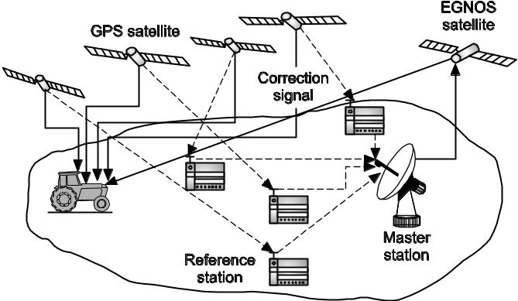
Fig. 5.4
• The ground GPS receiver, which calculates its 3D location from four or more satellites with help from a few ground reference stations and a master station.
Passive versus Active GPSes
• The GPS tracking makes it conceivable to track individuals, vehicles, and different resources, anyplace on Earth.
• There are two types of GPS following system: passive and active. In passive following, the GPS is only a receiver, not a transmitter. Passive GPS tracking do not have a transmission capacity to send the GPS information from the vehicle. In this way, passive GPS is otherwise called data loggers, utilized basically as recording gadgets.
• Active GPS following units fuse a strategy to transmit client data from a vehicle. Although satellite uplink of information is accessible, cell information correspondence is the most well-known and practical. Automatic incremental refreshing gives a persistent wellspring of following all through an account period. This gives current and in addition authentic logging positions. Passive GPS tracking store GPS area information in their interior memory which would then be able to be downloaded to a PC for review at a later time, while active GPS tracking systems send the information at consistent interims to be seen progressively.
• At the point when continuous information isn't required, uninvolved GPS tracking have a tendency to be supported more by singular purchasers for their minimized comfort and moderateness.
Operating Principles of GPS
• Knowing the separation from the collector to a settled position satellite suggests that the recipient is on the surface of a circle focused at the satellite. With four satellites, the collector area is distinguished at the convergence of four circle surfaces. The convergence of two satellite circles is a over when all is said in done. This circle could be decreased to a solitary point, if the two circles only touch on their surfaces. Having discovered those two meeting circle surfaces, now we consider how the crossing circle converges with a third satellite flag circle. A circle and a circle surface converge at zero, one, or two focuses. With the collector on the surface of Earth, the beneficiary needs to pick the point which is nearest to the collector from at most two crossing focuses. Clearly, this triangulation technique may bring about a few mistakes in narrowing down to precisely one point with at least error.
• To find the point precisely, the beneficiary needs to utilize a fourth satellite to sharpen in absolutely. The fourth satellite circle will come near the last two meeting purposes of three satellite circles. The last collector area is therefore chosen by taking note of the nearest point figured from the two last indicates the circle surface of the fourth satellite.
• On account of no mistake, the exact position is found. Something else, some counterbalance say, 10 meters from the correct area could be come about because of the mistake presented. To additionally decrease the blunders, more satellites could be included, yet this could be fairly exorbitant.
• Each satellite constantly transmits messages that incorporate the time the message was transmitted, precise orbital data (the ephemeris), and the general framework wellbeing and unpleasant circles of all GPS satellites (the chronicle). A GPS beneficiary ascertains its position by absolutely timing the signs sent by GPS satellites high above Earth. A GPS recipient must be bolted onto the flag of no less than three satellites to figure a 2D position (scope and longitude) and track development.
• With at least four satellites in see, the beneficiary can decide the client's 3D position (latitude, longitude, and altitude). Once the client's position has been resolved, the GPS unit can figure other information, such as speed, bearing, track, trip remove, separation to goal, dawn and dusk times, and then some.
• The recipient uses the messages it gets to decide the travel time of each message what's more, figures the separations to each satellite. These separations alongside the satellites' areas are utilized to process the position of the collector. This position is shown maybe with a moving guide show or scope, longitude, and height data. Numerous GPS units demonstrate inferred data for example, bearing and speed computed from positional changes.
5.4 Innovative Applications of the Internet of Things
In this section, we will review the application domains of the IoT. In particular, case study examples of the IoT are reported for applications in tracking, retailing, supply chain management, smart power grid, and smart buildings. Finally, cyber-physical system (CPS) projects for general-purpose applications.
Applications of the Internet of Things
The IoT has a considerable measure of military applications. By and large, utilization of the IoT intends to advance modern efficiency and raise efficient development. The IoT assumes imperative parts in condition assurance, including contamination control, climate anticipating, and debacle evasion what's more, recuperation. As far as societal effects, the IoT can make our lives more advantageous and agreeable. Government services, law enforcement, and home and health improvements are the major beneficiaries.
Specific Wireless Sensor Applications
Featured underneath are a few uses of sensor networks:
• Military sensor networks to identify and pick up however much data as could reasonably be expected about foe developments, blasts, and other wonders of intrigue.
• Sensor networks to identify and describe compound, natural, radiological, atomic, and hazardous assaults and materials.
• Sensor networks to identify and screen ecological changes in fields, woodlands, seas, etc
• Wireless traffic sensor networks to screen vehicle activity on expressways or in congested parts of a city.
• Wireless surveillance sensor networks for giving security in shopping centers, parking structures, and different offices.
• Wireless parking area sensor networks to decide if the part is possessed or accessible.
Smart Power Grid and Smart Buildings
Environmental assurance is a worldwide issue. Environmentally friendly power vitality is wanted to spare vitality and to lessen the impacts of an unnatural weather change. A basic IoT application is advancement of a smart power lattice.
Smart Power Grid
Different power organizations over the United States have or are redesigning their energy administration and conveyance frameworks. Different sensors at singular homes (smart thermostats)can gather data that is sent through a system to principle stations (maybe even nearby "center points") that can apply complex power administration and send control signals back to the grid to save energy. . The shrewd matrix is made conceivable by applying detecting, estimation, and control gadgets to power creation, transmission, circulation, and utilization.
Smart Buildings
The IoT could improve our lives with solace, accommodation, and security, and lessen vitality costs and natural effects. The IoT has been proposed in development of savvy structures in residential, commercial, mechanical, and government settings. This may incorporate alarm systems, access controls, indoor atmosphere controls, lifts, etc. We want to diffuse IT into lighting, machines, and furniture in structures. A smart building can be a shopping center or a home, a clinic or a skyscraper office tower. Shrewd structures require checking and direction of warming, aerating and cooling, lighting, and natural changes. They can administer building security, fire concealment, and lift operations. Savvy building advances concentrate on bringing more point by point observing and detecting "awareness" to structures.
Retailing and Supply-Chain Management
IoT applications will advance business, enhance our general public, and improve practical development. These incorporate particular IoT applications in railing and logistics administrations and production network administration. Numerous mechanical, government, and group administrations can profit by these applications. These incorporate exercises or activities to advance the improvement of better and more productive social orders, urban areas, and governments.
Retailing and Logistics Services
Emergence of RFID applications depends strongly on adoption by retailers, logistics organizations, and package-delivery companies. In particular, retailers may tag individual objects in order to solve a number of problems at once: accurate inventorying, loss control, and ability to support unattended walk-through point of sale terminals (which promise to speed checkout while reducing both shoplifting and labor costs). Cold-chain auditing and assurance could require tagging food and medicine with temperature-sensitive materials and/or electronics; ensuring or monitoring whether perishable materials are intact and/or need attention may entail communications among things, refrigeration systems, automated data logging systems, and human technicians.
For example, at the grocery store, you buy a carton of milk. The milk container would have an RFID tag that stores the milk’s expiration date and price. When you lift the milk from the shelf, the shelf would display the milk’s specific expiration date, or the information could be wirelessly sent to your personal digital assistant or cell phone.
5.4.1 Supply Chain Management
• Supply chain management can be helped by an IoT framework. The thought is to deal with an entire system of related organizations or accomplish engaged with item assembling, conveyance, and administrations as required by end clients. At any given time, advertise powers could request changes from providers, logistics suppliers, areas and clients, and any number of particular members in a supply chain. This changeability effect slowly affects the store network framework, running from the establishment layers of setting up the electronic correspondence between the exchanging accomplices to the more complex setup of the procedures and the plan of work processes that are fundamental to a quick generation process.
• A supply line consolidates the procedures, philosophies, apparatuses, and conveyance choices to manage communitarian accomplices to work in a grouping to lead business with high productivity and conveyance speed. The agreeable organizations must work in bolt step rapidly as the intricacy and speed of the store network increment because of the impacts of worldwide rivalry, fast value vacillations, surging of oil costs, short item life cycles, extended specialization, and ability shortage.
• A store network is a productive system of offices that gets materials, changes these materials to wrapped up items, lastly disperses the completed items to clients. The accompanying case could clarify how the store network can be supported by the IoT, which is especially custom fitted to advance business proficiency and quick development.

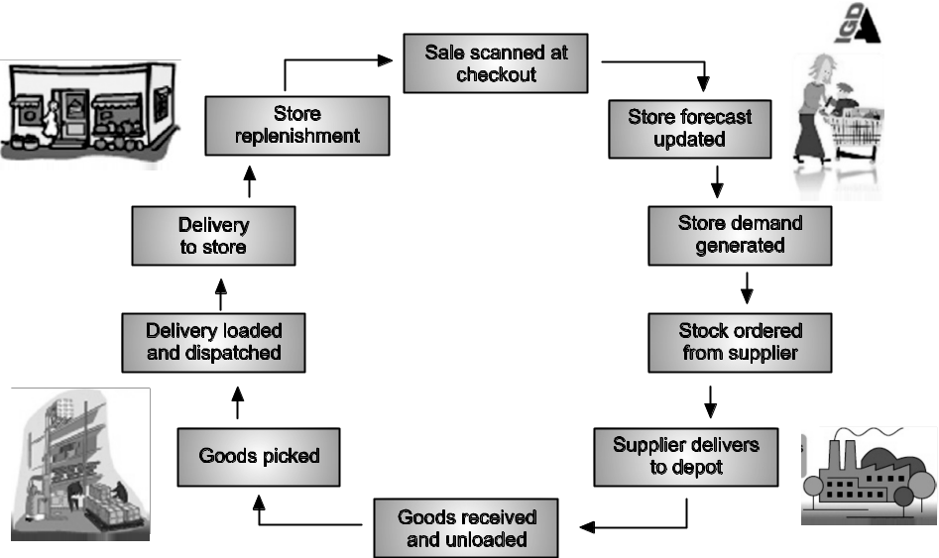
Fig. 5.5: Supply chain management in the multipartner business arena

• Inventory network administration is a procedure utilized by organizations to guarantee that their production network is proficient and financially savvy.
• Fig. 5.5 delineates the inventory network for the creation and offer of buyer items. The production network includes material or part providers, appropriation focuses, correspondence joins, cloud server farms, an extensive number of retail locations, corporate central command (e.g., Wal-Mart), and bank installments.
• These business accomplices are connected by satellite, Internet, wired and remote systems, truck, prepare, or delivering organizations, and electronic saving money, cloud suppliers, et cetera. Sensors, RFID labels, and GPS gadgets could be set wherever along the store network. The thought is to advance online business, web based business, or portable exchanges. Production network administration comprises of five noteworthy stages:
Stage 1: Planning and Coordination: An arrangement or system must be created to address how a decent or administration can fulfill the requirements of clients.
Stage 2: Material and Equipment Supplies: This stage includes building a solid association with the crude material providers and arranging techniques for transportation, conveyance, and installment.
Stage 3: Manufacturing and Testing: The item is tried, made, and booked for conveyance.
Stage 4: Delivery of Products Customer orders are taken and conveyance of merchandise is arranged.
Stage 5: After-Sale Service and Returns Customers may return flawed items and the organization addresses clients' requests. Inventory network programming is utilized by many organizations for proficient production network administration.

